EduGenie: Google Gemini Powered Learning Assistant

Project Description:
EduGenie harnesses Generative AI to provide an intelligent and personalized learning experience for students. The platform includes an Explanation module, which explains any topic in simple terms, a Q&A module, which answers learner questions, a Quiz Generation module, which creates multiple-choice questions from a given passage, a Summarization module, which condenses long text into simple language, and a Learning Path module, which recommends a structured, adaptive study plan for any topic.
Utilizing the Google Gemini API through the google-generativeai library, EduGenie processes user inputs to deliver fast, clear and helpful learning content. Built with a FastAPI backend and an HTML/CSS frontend, and run locally with Uvicorn, the platform ensures a simple and user-friendly experience for students, teachers and self-learners.

Scenarios
Scenario 1: A student is confused about quantum computing and types the topic into the Explanation module. EduGenie returns a simple, easy-to-follow explanation in seconds.
Scenario 2: A learner pastes a passage about the Pythagorean theorem into the Quiz module. The system generates three multiple-choice questions with four options each, and the learner can check every answer instantly.
Scenario 3: A beginner wants to learn SQL and enters the topic in the Learning Path module. EduGenie recommends a structured path with key topics, learning order, estimated time and resources at beginner, intermediate and advanced levels.

Technical Architecture:

Description: EduGenie uses a modular architecture. The frontend (HTML and CSS) collects the user input and displays the results. The FastAPI backend receives each request and routes it to the matching module: Explanation (/explain), Q&A (/qa), Quiz Generation (/quiz), Summarization (/summarize) and Learning Path (/learn/recommendations). Each module builds a prompt, calls the Google Gemini model, and returns the response, which the frontend then shows to the user.
Note: EduGenie does not use a database, so an ER diagram is not applicable.

Pre-requisites:
- FastAPI Framework Knowledge: FastAPI documentation
- Google Gemini API Familiarity: Google AI Studio and Gemini API documentation
- HTML and CSS Skills: W3Schools HTML/CSS tutorials
- Python Programming Proficiency: Python documentation
- Version Control with Git: Git documentation
- Uvicorn: ASGI server used to run the FastAPI application

Project Workflow:

Milestone 1: Model Selection and Architecture
- Activity 1.1: Generate a Google Gemini API key and configure it securely in the project environment.
- Activity 1.2: Research and select the appropriate Gemini model for educational content generation.
- Activity 1.3: Define the architecture of the application, detailing interactions between the frontend, backend and AI integration.
- Activity 1.4: Set up the development environment, installing necessary libraries and dependencies.

Milestone 2: Core Functionalities Development
- Activity 2.1: Develop the core learning modules: Explanation, Q&A, Quiz Generation, Summarization and Learning Path.
- Activity 2.2: Implement the FastAPI backend to manage routing and user input processing.

Milestone 3: main.py Development
- Activity 3.1: Write the main application logic in main.py, establishing routes for each feature and integrating AI responses.

Milestone 4: Frontend Development
- Activity 4.1: Design and develop the user interface using HTML and CSS.
- Activity 4.2: Render the results of each module dynamically on the page based on user interactions.

Milestone 5: Deployment
- Activity 5.1: Prepare the application for local deployment by installing all dependencies.
- Activity 5.2: Run the application locally using Uvicorn and verify every module.

Milestone 6: Conclusion

Milestone 1: Model Selection and Architecture
In this milestone, we select the Google Gemini model that best fits the learning-assistant needs of EduGenie, and set up the environment required to call it securely.

Activity 1.1: Generate a Google Gemini API Key
- Step 1: Visit Google AI Studio and sign in with your Google account.
- Step 2: Open the API Keys section and click Create API Key.
- Step 3: Copy the key immediately and store it in a safe place.
- Step 4: Add the key to your project environment as required by the source code, and never commit it to a public repository.

Activity 1.2: Research and Select the Appropriate Generative AI Model
- Understand the Project Requirements: Explanations, answers, quizzes, summaries and learning paths for students.
- Explore the Gemini Documentation: Review the available models, their speed, context window and limitations.
- Select the Model: The project uses the Gemini Pro model (models/gemini-1.5-pro) through the google-generativeai library for its balance of response quality and reasoning ability.

Activity 1.3: Define the Architecture of the Application
- Frontend: Users enter a topic or text, choose a feature, and view the results.
- Backend: FastAPI receives requests and routes them to the correct module.
- AI Integration: Each module builds a task-specific prompt, calls Gemini, and returns the response.

Activity 1.4: Set Up the Development Environment
- Python: Install Python 3 and pip.
- Dependencies: Install all libraries listed in requirements.txt.
pip install -r requirements.txt
- Project structure: Create the following folders and files.
edugenie/
├── static/style.css
├── templates/index.html
├── main.py
├── explanation_module.py
├── qna.py
├── quiz_module.py
├── summary_module.py
├── learning_path.py
└── requirements.txt

Milestone 2: Core Functionalities Development

Activity 2.1: Develop Core Learning Features
- Explanation Module: Explains any topic in simple language (/explain).
- Q&A Module: Answers questions asked by the learner (/qa).
- Quiz Generation Module: Creates three multiple-choice questions from a passage. Each question has four options and one correct answer. The module asks Gemini for JSON output and removes any markdown code fences before parsing (/quiz).
- Summarization Module: Summarizes the given text in simple language (/summarize).
- Learning Path Module: Acts as an AI tutor and returns a structured, adaptive learning path with key topics, order of learning and resources at beginner, intermediate and advanced levels (/learn/recommendations).

Activity 2.2: Implement the FastAPI Backend
- Routes: Set up routes in main.py for the home page and each learning module.
- Input validation: Return a 400 error when the required input (for example the quiz text) is empty.
- Error handling: Each module wraps the Gemini call in try/except and returns a readable error message if the call fails.

Milestone 3: main.py Development
main.py is the backbone of EduGenie. It creates the FastAPI app, serves the frontend page, and defines the API routes.
GET / -> renders index.html
POST /explain -> topic explanation
POST /qa -> question answering
POST /quiz -> {"text": ...} returns {"quiz": [...]}
POST /summarize -> text summary
GET /learn/recommendations -> ?topic=... returns {"topic", "recommendation"}

- The application is started with Uvicorn and reloads automatically when the code changes.

Milestone 4: Frontend Development

Activity 4.1: Designing the User Interface
- Develop index.html as the single-page interface with an input area for each feature.
- Style the page with static/style.css to keep the layout clean, readable and easy to use.

Activity 4.2: Dynamic Content Rendering
- Send the user input to the matching FastAPI endpoint and display the returned explanation, answer, summary, quiz or learning path on the same page.
- For quizzes, show each question with four options and a Check Answer button that reports whether the selected option is correct.

Milestone 5: Deployment

Activity 5.1: Preparing the Application for Local Deployment
- Open the project folder in a terminal or VS Code.
- Install all dependencies from requirements.txt.
- Make sure the Google Gemini API key is available as required by the source code.

Activity 5.2: Local Testing and Verification
- Start the FastAPI server:
uvicorn main:app --reload
- Open http://127.0.0.1:8000 in the browser.
- Test every module: explanation, Q&A, quiz, summary and learning path, and confirm the responses are generated and displayed correctly.

Exploring the Website’s Web Pages:

Explanation Page:
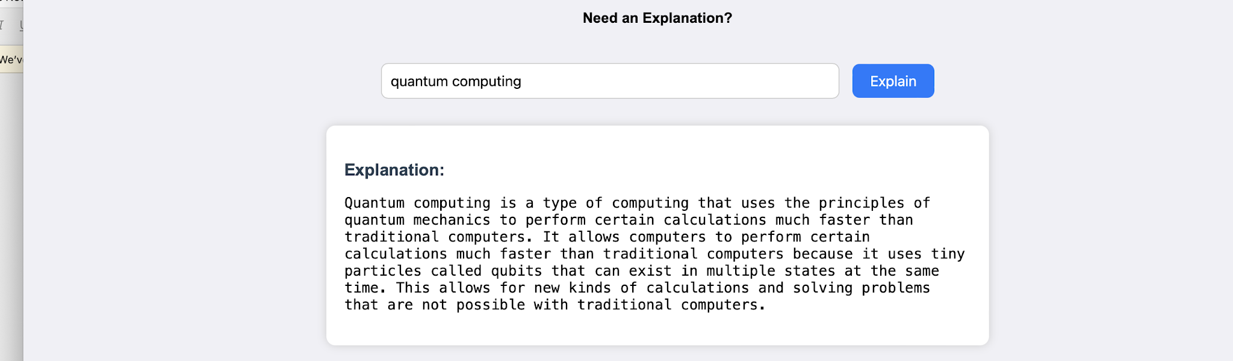
Description: The user types a topic, such as quantum computing, and clicks Explain. The explanation is shown in a card below the input box.

Quiz Page:
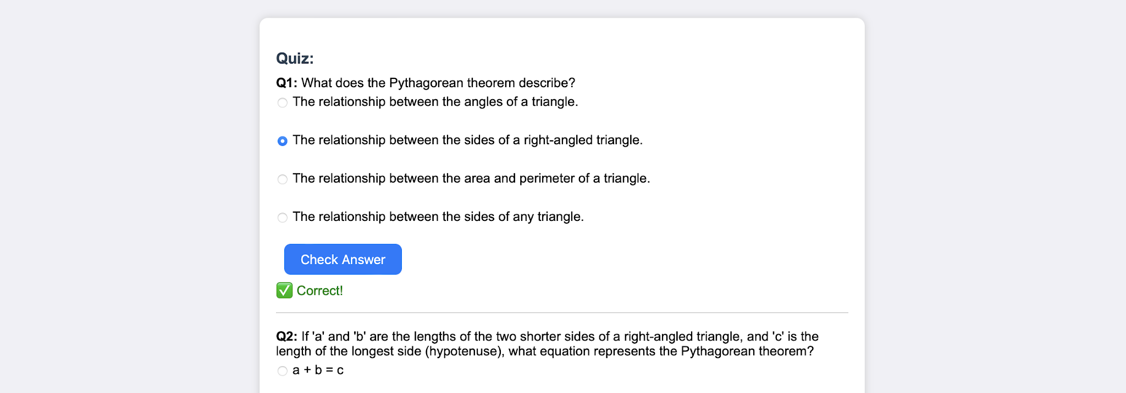
Description: The generated quiz shows each question with four options. The user selects an option and clicks Check Answer to see instantly whether it is correct.

Conclusion:
EduGenie is a generative AI learning assistant built with FastAPI and powered by Google Gemini. It brings explanations, question answering, quiz generation, summarization and personalized learning paths together in a single simple interface. The project, which covered model selection, backend and frontend development, and local deployment with Uvicorn, shows how targeted AI prompts and a modular structure can make self-learning faster and more engaging. In the future, EduGenie can be extended with user login to save learning history, support for more languages, cloud deployment for public access, and progress tracking across quizzes.

